**BA/DA TRAINING**

**BCNF Assignment – 10(July18,2019)**

**SHAFALI GUPTA**

1. **Explain BCNF.**

**Ans:- Boyce-Codd Normal Form (BCNF) -** To satisfy the Boyce-Codd Normal Form, it should satisfy the following two conditions:

1. It should be in the **Third Normal Form**. That means If all attributes of relation are prime attribute, then the relation is always in 3NF.
2. And, for any dependency A → B, A should be the **super key** of the table.

For an example, below we have a college enrolment table with columns student_id, subject and professor

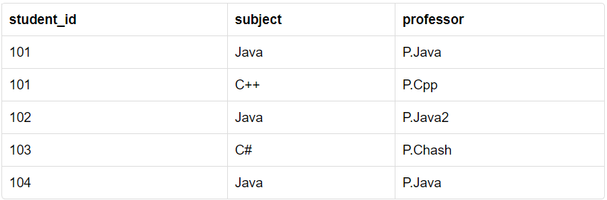

In the table above:

* One student can enroll for multiple subjects. For example, student with **student_id** 101, has opted for subjects - Java & C++
* For each subject, a professor assigned to the student.
* In addition, there can be multiple professors teaching one subject like the one we have for Java.

In the table above **student_id, subject** together form the primary key, because using “student_id” and “subject”, we can find all the columns of the table

Another important point is, one professor teaches only one subject, but one subject may have two different professors.

Hence, there is a dependency between subject and professor here, where subject depends on the professor name.

This table satisfies the **1st Normal form** because all the values are atomic, column names are unique and all the values stored in a particular column are of same domain.

This table also satisfies the **2nd Normal Form** as there is no **Partial Dependency**.

In addition, there is no **Transitive Dependency**; hence, the table also satisfies the **3rd Normal Form**.

However, this table is not in **Boyce-Codd Normal Form**.

**This table is not in BCNF**

In the table above, “student_id”, “subject” form primary key, which means subject column, is a prime attribute.

However, there is one more dependency, professor → subject.

In addition, while **subject** is a prime attribute, **professor** is a non-prime attribute, which is not allowed by BCNF.

To make this relation(table) satisfy BCNF, we will decompose this table into two tables, **student** table and **professor** table.

Below we have the structure for both the tables.

**Student Table**

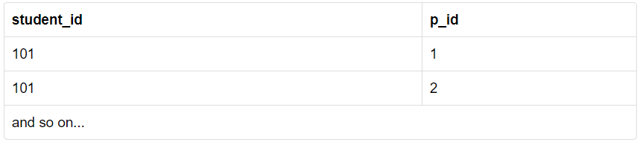

**Professor Table**

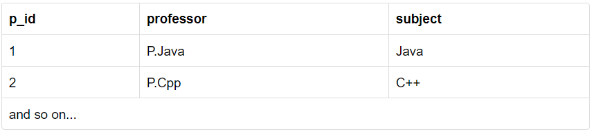

And now, this relation satisfy Boyce-Codd Normal Form.